Assessment Methodologies: Information Gathering CTF 1

Task 01:
This tells search engines what to and what not to avoid.
Solution:
Robots.txt

We have to visit the robots.txt so I visit the https://target.ine.local/robots.txt
then i get the flag:
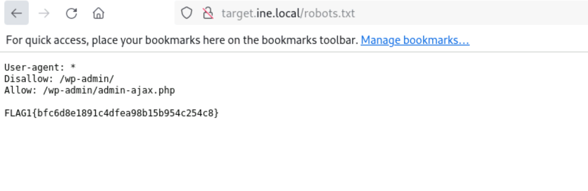
Answer:
bfc6d8e1891c4dfea98b15b954c254c8
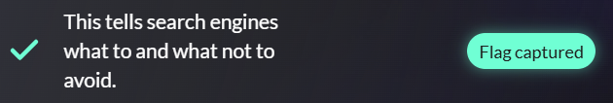

Task 02:
What website is running on the target, and what is its version?
Solution:
For this I use the command of the whatweb to check the version:
Whatweb https://target.ine.local/
Then:
Answer:
89bf7a8373644e88ae11e0ee1c908650
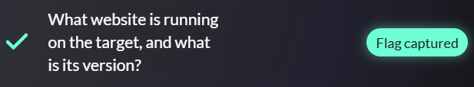

Task 03:
Directory browsing might reveal where files are stored.
Solution:
Here I use the dirb:
The purpose of dirb is to perform brute-force directory and file discovery on a web server. It helps identify hidden or unlinked directories/files that are not visible in the site’s navigation but still exist on the server.
Dirb http://target.ine.local/
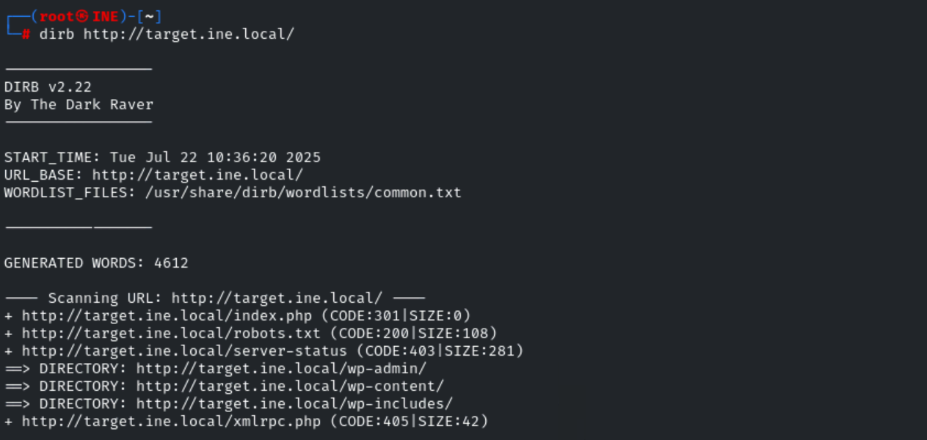
The upload looks something :
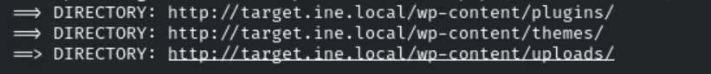

http://target.ine.local/wp-content/uploads/
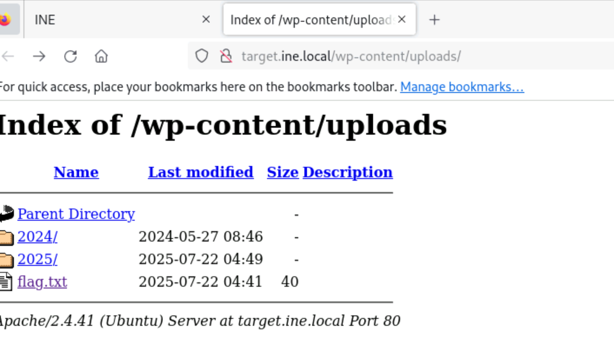
Then flag:
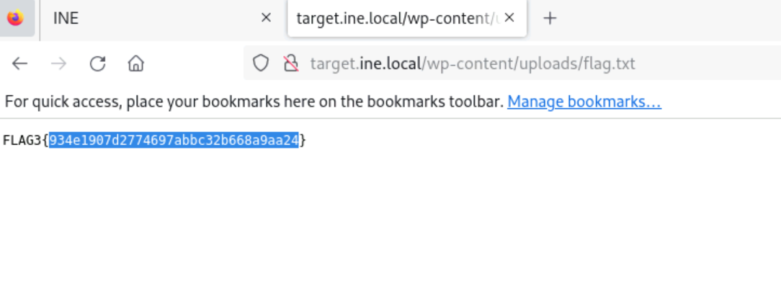
Answer:
934e1907d2774697abbc32b668a9aa24
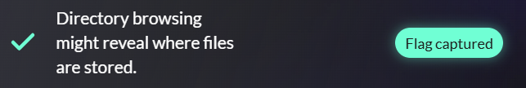

Task 04:
An overlooked backup file in the webroot can be problematic if it reveals sensitive configuration details.
Solution:
Scan for common backup extension:
dirb http://target.ine.local -X .bak,.tar.gz,.zip,.SQL
then:
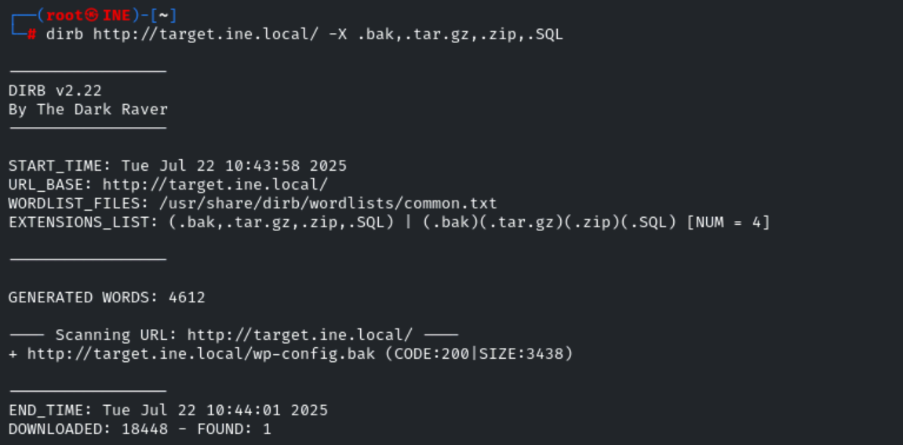

Then:
Download the webpage:
curl http://target.ine.local/wp-config.bak
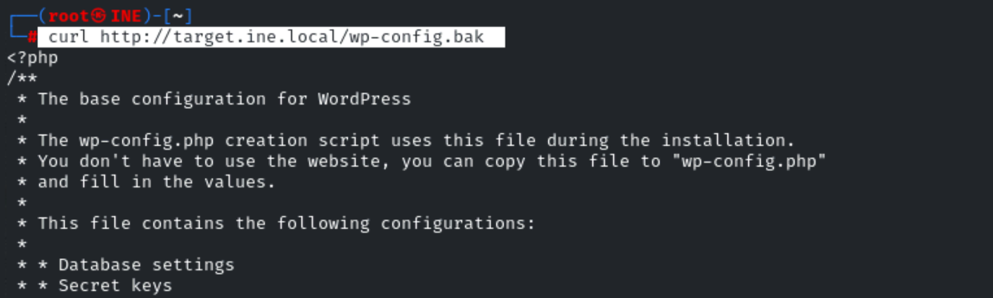
It show the flag:
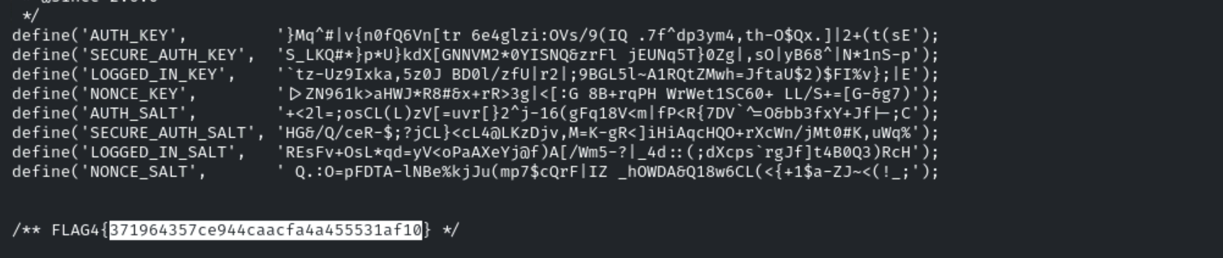
Answer:
371964357ce944caacfa4a455531af10
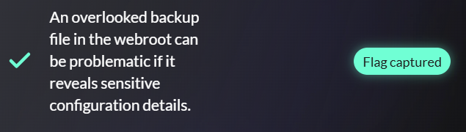

Task 05:
Certain files may reveal something interesting when mirrored.
Solution:
httrack http://target.ine.local/ -O ./web.html
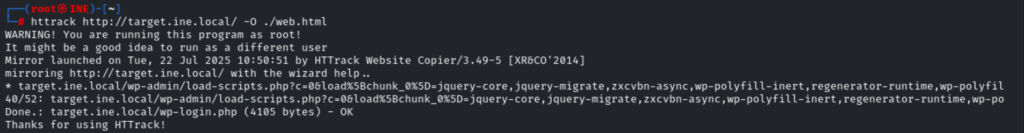

After mirroring, .php file names are checked because they may reveal admin areas, functional endpoints, or vulnerabilities that aren't immediately visible on the public site.

Then:
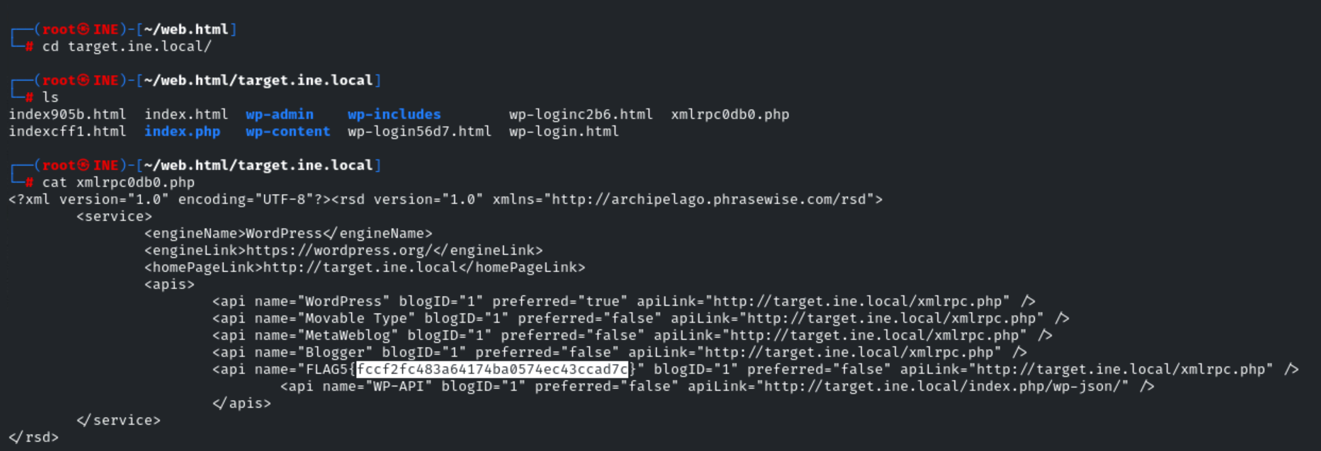
Answer:
fccf2fc483a64174ba0574ec43ccad7c
